Title: AI-TOPSCS
Description: AI-based tomato operation, production, and supply chain system.
Designing and Disseminating information systems about crop planning, production practices, market intelligence, farmer/ trader/ customer interface, etc. (Remote Sensing, Artificial Intelligence, app-based platforms, etc.)
Our TAAS will pertain growth of tomatoes till exporting. TAAS is an Android-based application that will be user-friendly and provide relevant pieces of information to growers, nurseries, transporters, traders, and processors.TAAS Provides Digital interventions for site-specific information dissemination on cultivars and production technologies. Using remote sensing, AI, and App-based interventions.
Abstract:
The Tomato supply chain (TSC) encompasses several crucial stages that necessitate planning at least two months ahead. Therefore, having an accurate forecast of tomato yield well in advance is essential for making timely and informed decisions regarding resource allocation, transportation logistics, and cold storage contracts, among other factors. Any overestimation or underestimation of tomato yield can result in significant inefficiencies within the TSC. Recognizing its paramount importance, we propose a method based on machine learning (ML) techniques that leverages satellite-based vegetation data. This method, known as the satellite image-based Method for Tomato Production Forecast (SIBM-TPF), delves into the Normalized Difference Vegetation Index (NDVI) data collected at various phenological stages to capture both spatial and temporal dependencies in tomato yield forecasting.
In the initial phase of SIBM-TPF, a clustering process is employed, utilizing the georeferenced NDVI data from all phenological stages as input, resulting in the identification of several clusters. Subsequently, in the second step, two validation functions are applied to determine the optimal clustering approach. Finally, in the third step, the predictor variables from the best clustering are incorporated into an artificial neural network (ANN) for the prediction of tomato yield. SIBM-TPF was successfully applied to forecast the table of vegetable yields in a selected region of the country. We are expecting the results to be 95 % accurate for forecasting the yield of Tomato at least two months in advance. These results are incorporated with our e-market service web platform for effective supply chain management of tomatoes. The implementation of SIBM-TPF offers stakeholders the opportunity to make more informed decisions, enhancing the coordination of TSC stages while simultaneously reducing costs and minimizing tomato losses.

Idea:

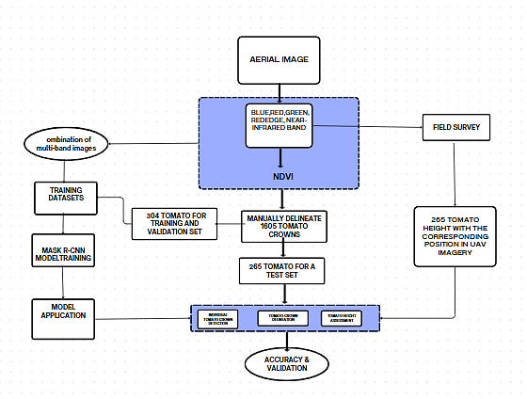
Growers

Nurseries

Transporters

Traders, Exporters

People
- In the TAAS app the main idea is to provide all the services in a single platform.
- The farmer who cultivates tomatoes can directly connect to the traders and exporters.
- Collecting satellite imagery from the required areas to be monitored.
- After Collecting the images, identify the tomato cultivating land.
- Identifying the other near tomato cultivating lands.
- After training our models using ML algorithms, the tomato-cultivating land is identified. Then the vegetation’s current growth rate is identified using NDVI.NDVI=(NIR-RED)/(NIR+RED).
- The output image shows the cultivated regions where the tomatoes are healthy.
- So, the traders and exporters can easily access the better yield (high-grade) tomatoes.
- And also, the low-grade tomatoes can be circulated to the local area vendors.
- TAAS provides all with online marketing, payment services and expert assistance, reviews.
- By using real time market intelligence all the information are collected from growers, nurseries,transporters,traders,exporters.
- As a first step there will be a different login for growers, nurseries,transporters,traders,exporters.
- If a grower login, then he/she will find an information about the tomato cultivation, nurseries to get seeds and fertilizers. with expert assistance and farmers reviews. and also, the high-grade cultivating land will be shown to the farmers.
- If a nursiers login then he/she will find an information about the tomato cultivation, and farmers need to cultivation.
- If a transporter login, then he/she will find an information about the farmers and track their locations available in the app and delivery the tomatoes to the traders easily.
- Payment services are also provided between transporter and traders.
- If a trader login, then he/she will find all the information about the growers, nurseries, transporters, and also the kilograms of tomatoes needed and locations of the lands.
- After that an exporter will export to other mediums such as super markets, other states, local places.
- TAAS provides high integrity and user interface so, anyone can access.
- The Tomato supply chain (TSC) encompasses several crucial stages that necessitate planning at least two months ahead. Therefore, having an accurate forecast of tomato yield well in advance is essential for making timely and informed decisions regarding resource allocation, transportation logistics, and cold storage contracts, among other factors. Any overestimation or underestimation of vegetable yield can result in significant inefficiencies within the TSC. Recognizing its paramount importance, we propose a method based on machine learning (ML) techniques that leverages satellite based vegetation data. This method, known as the satellite image-Based Method for Tomato Production Forecast (SIBM-TPF), delves into the Normalized Difference Vegetation Index (NDVI) data collected at various phenological stages to capture both spatial and temporal dependencies in tomato yield forecasting.
- In the initial phase of SIBM-TPF, a clustering process is employed, utilizing the georeferenced NDVI data from all phenological stages as input, resulting in the identification of several clusters. Subsequently, in the second step, two validation functions are applied to determine the optimal clustering approach. Finally, in the third step, the predictor variables from the best clustering are incorporated into an artificial neural network (ANN) for the prediction of tomato yield. SIBM-TPF was successfully applied to forecast table of vegetable yields in an selected region of the country. We are expecting the results are 95 % accurate for forecasts the yield of Tomato at least two months in advance. These results are incorporated with our e-market service web plat form for effective supply chain managemt of toamatos.The implementation of SIBM-TPF offers stakeholders the opportunity to make more informed decisions, enhancing the coordination of TSC stages while simultaneously reducing costs and minimizing fruit losses.

